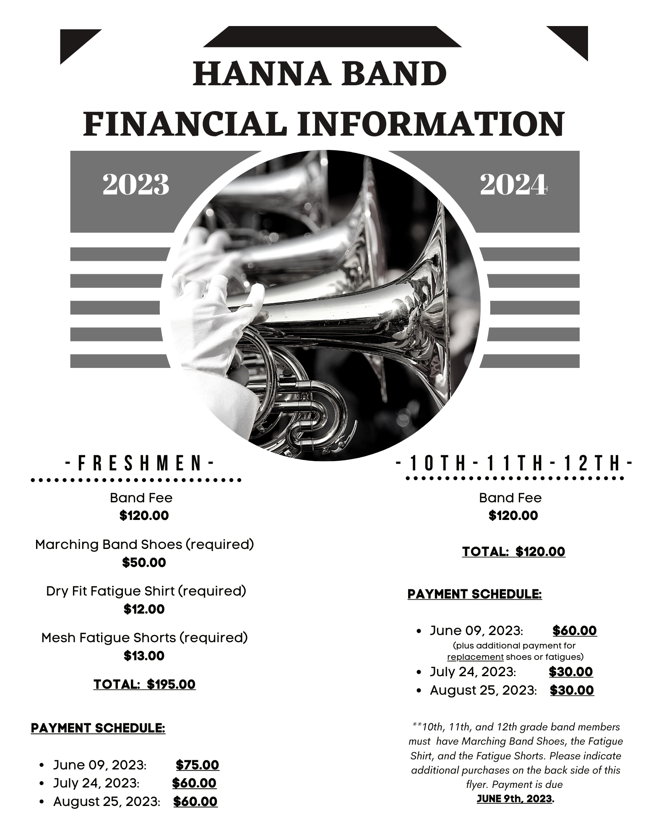

FRESHMEN ONLY:
This form is required and due with $75.00 by June 9, 2023.

First Name: _____________________________________________________

Last Name: _____________________________________________________

Instrument/Section: _____________________________________________________

2023-2024 Grade Level: _________________

(Circle one)
Adult T-Shirt Size: XS S M L XL 2X 3X

(Circle one)
Adult Short Size: XS S M L XL 2X 3X

Shoe Size: Men’s__________ or Women’s__________
10TH, 11th, 12TH GRADES ONLY:
Please submit this form if you need to order additional fatigues or a replacement pair of marching band shoes.
Due June 9, 2023 with $50.00 plus the cost of any items you are ordering.

Band Fee Payment No. 1: $50.00

Select any of the following that you will be ordering and indicate size(s) above.
______ Fatigue Shirt $12.00

______Fatigue Shorts $13.00

______Marching Shoes $50.00

Total: $________________________

